**The Flying Saucer Test Plan**

**Entrees**

1. Fire up The Flying Saucer PointOfSale project. It should look like this. 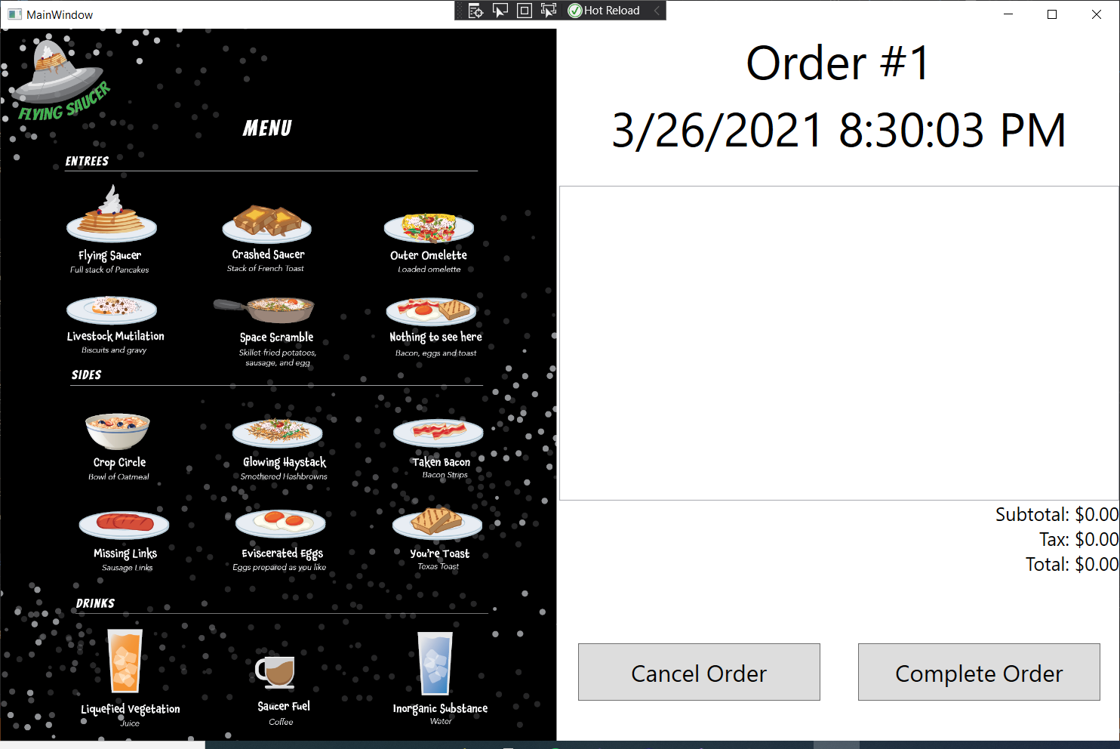
2. Click on the Flying Saucer icon to open up the customization menu for that item. The initial screen should look like this, with the Maple button being the only button selected and a flying saucer item added to the box on the right.

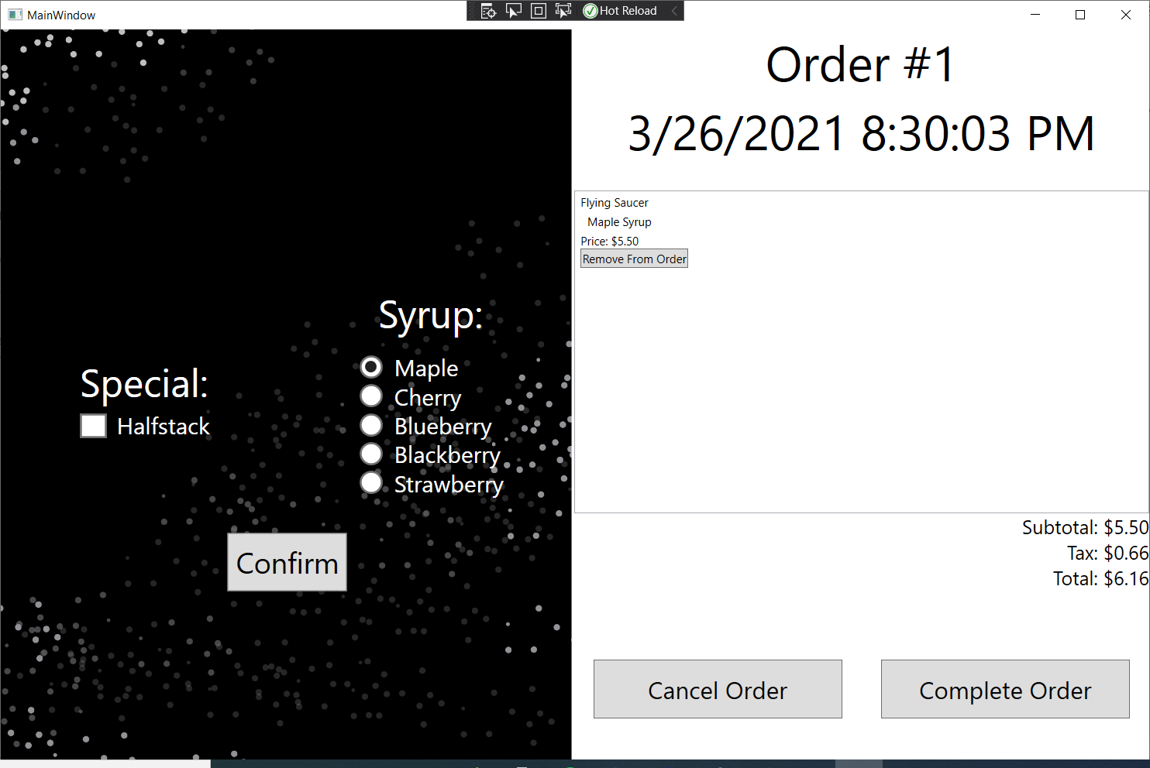

1. 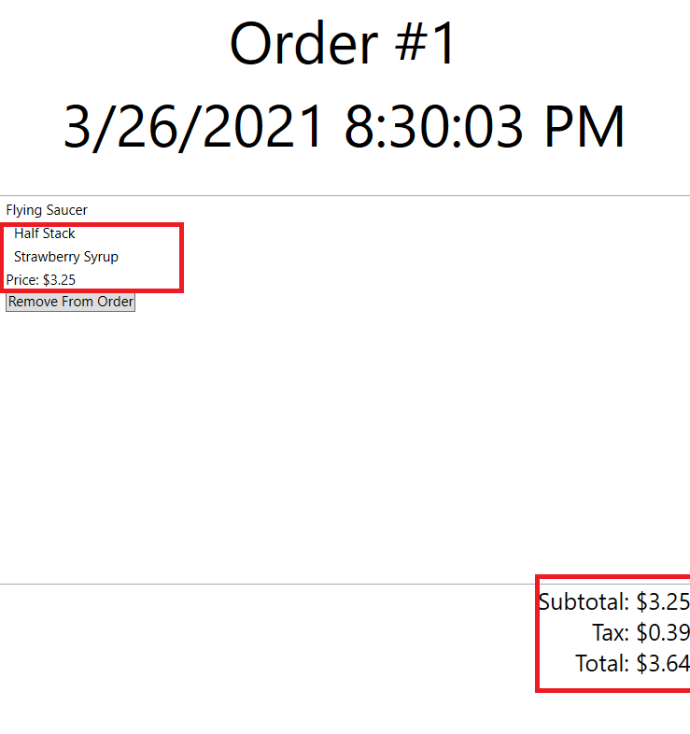Click on the Halfstack button and the Strawberry button. There should now be the text “Half Stack” and “Strawberry Syrup” in the box containing the order, as well as an adjusted price.
2. Click “Confirm” to go back to the main selection page and select the entrée “Space Scramble” to open a screen similar to step 2.
3. Click “Confirm” again to go back to the main selection page. Now click the bottom-most “Remove from order” button in the box containing the order. This should remove the Space Scramble item from the order form.

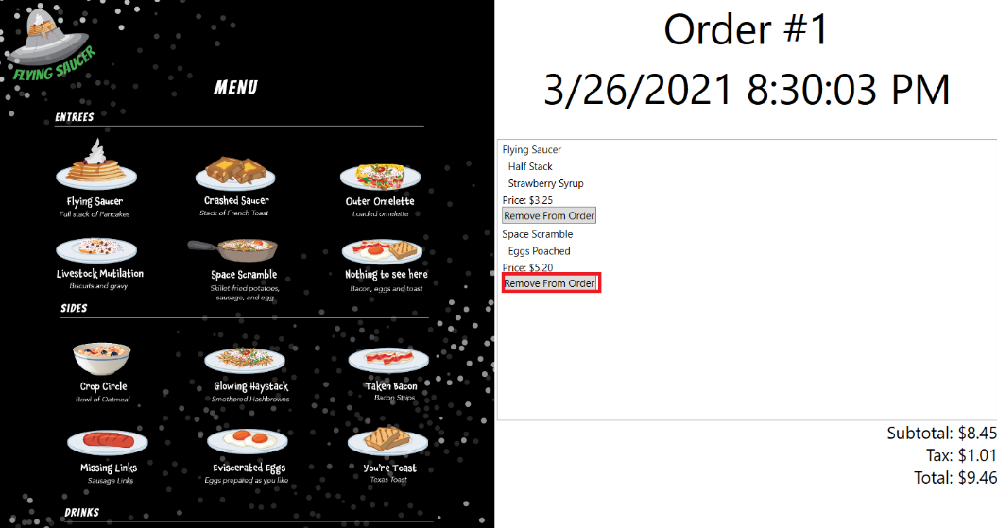

1. Click in the highlighted area to edit the existing Flying Saucer entrée. 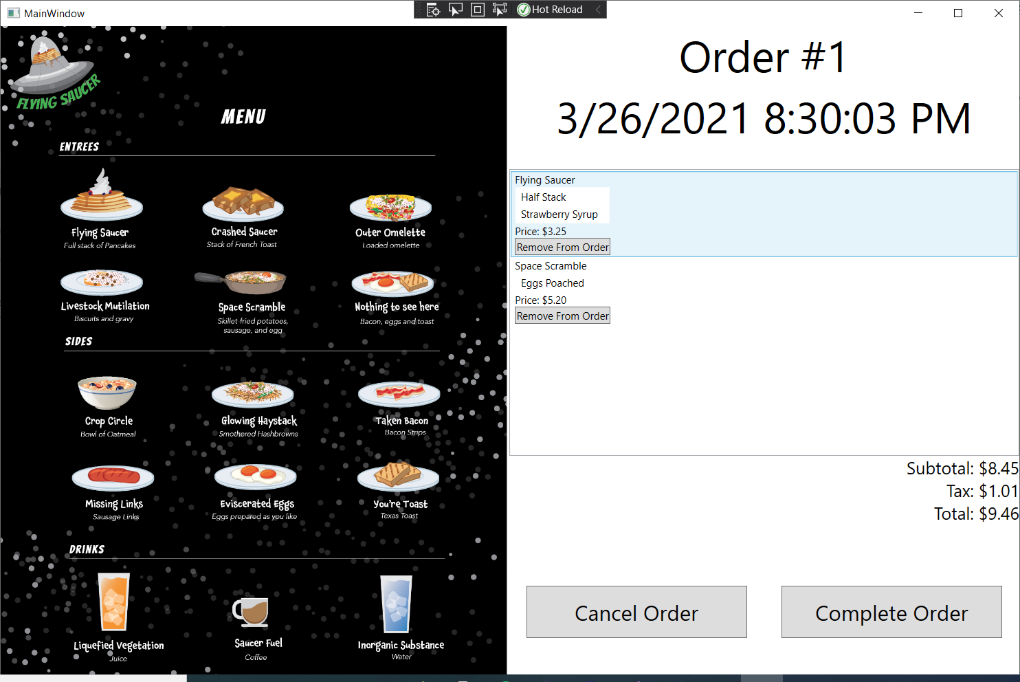
2. Un-check the “Halfstack” button. The order form should now look like this: 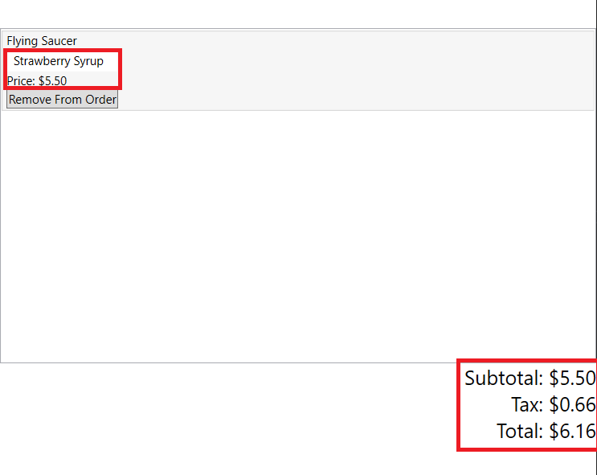
3. Press confirm and then press the “cancel order button” to clear the order form and start a new order.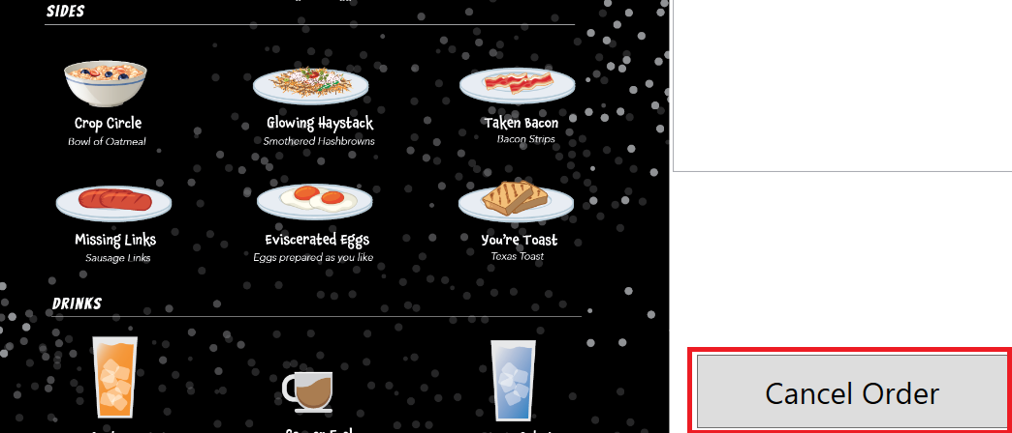

**Sides**

1. Keep open the existing PointOfSale project from the entrees section. The window should look like this. 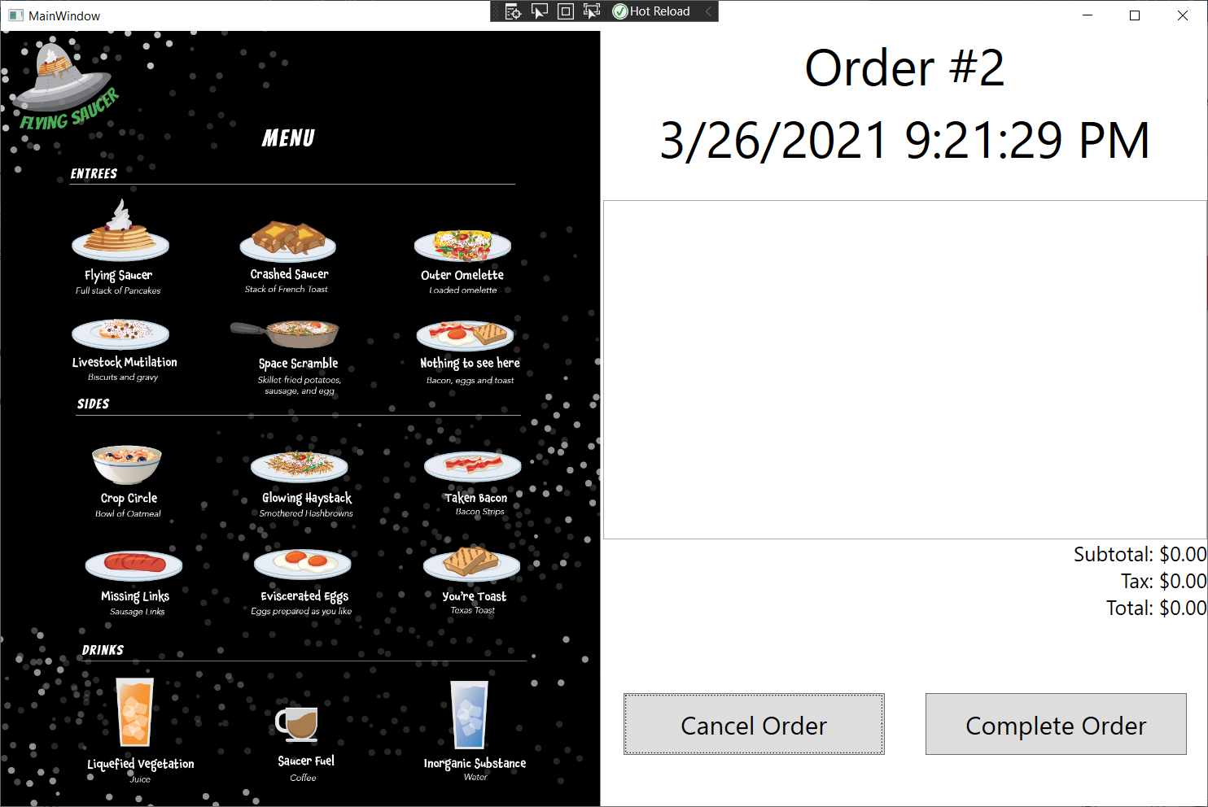
2. Click on the Glowing Haystack icon to open up the customization menu for that item. The initial screen should look like this, with the Sauce and Medium buttons being selected and a glowing haystack item added to the box on the right. 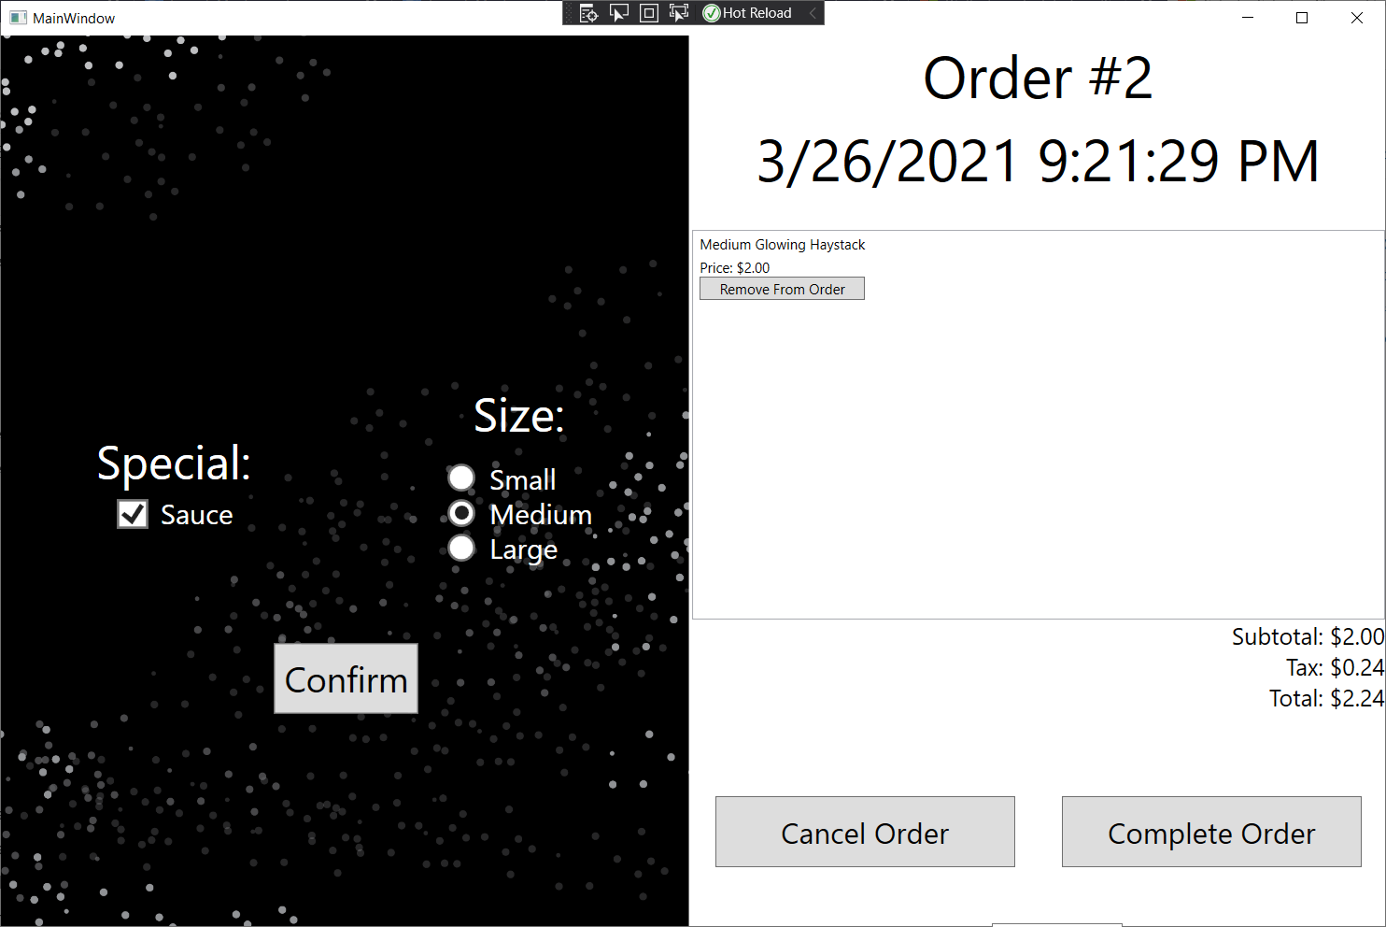

1. Click on the Small button. There should now be the text “Small Glowing Haystack” in the box containing the order, as well as an adjusted price.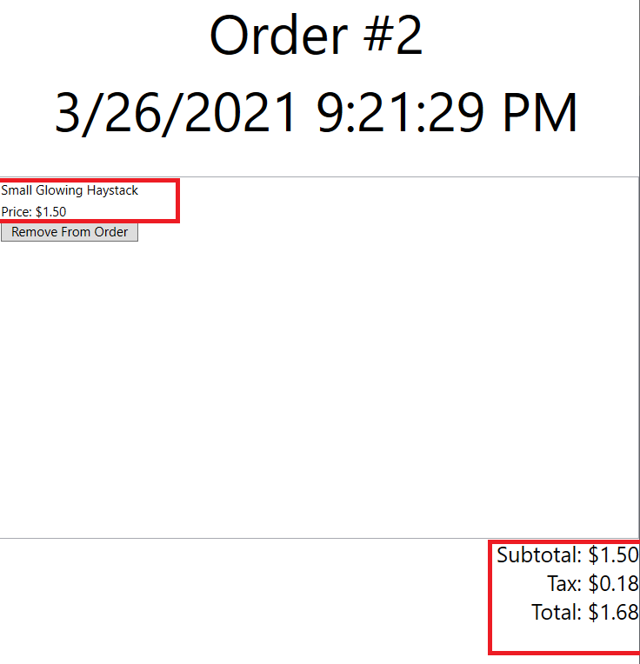
2. Click “Confirm” to go back to the main selection page and select the side “Taken Bacon” to open a screen similar to step 2.
3. Click “Confirm” again to go back to the main selection page. Now click in the highlighted area to edit the existing Taken bacon side.

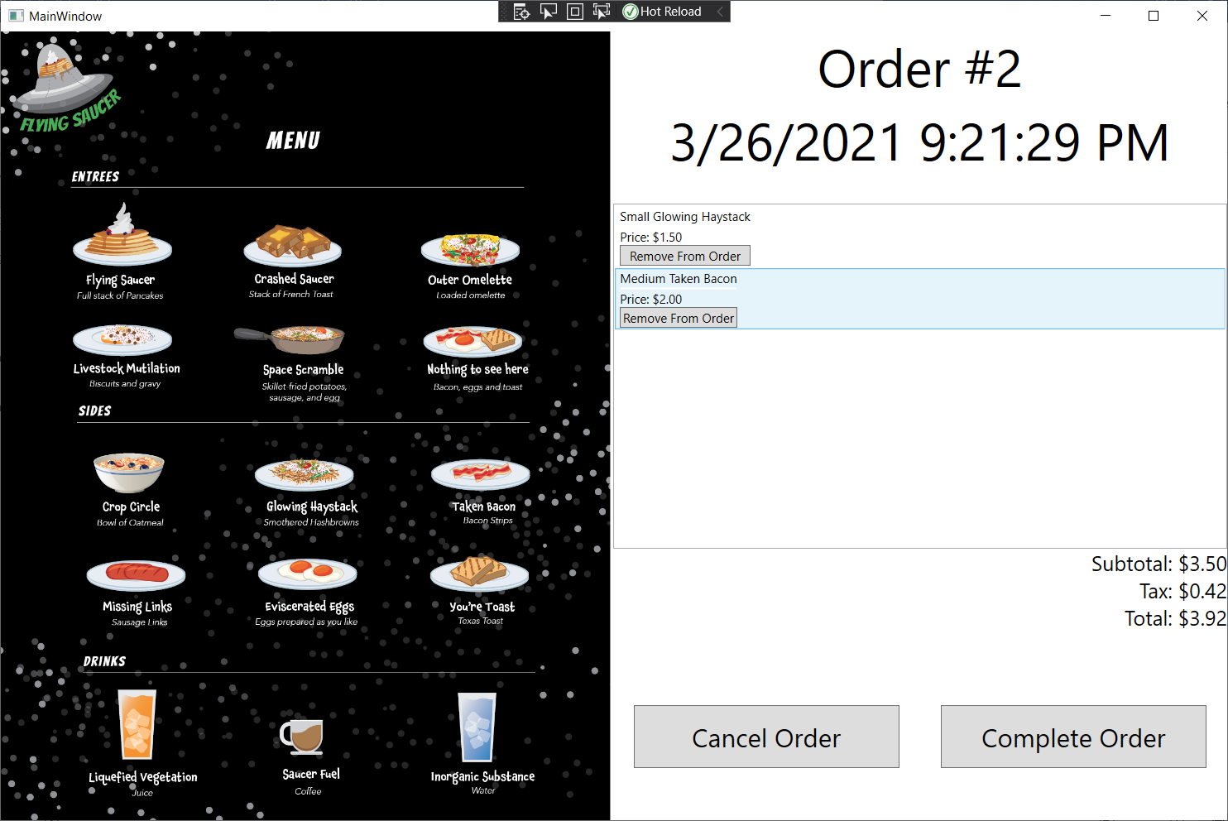

1. Click the “Large” button to adjust the size of the side. The order form should now be: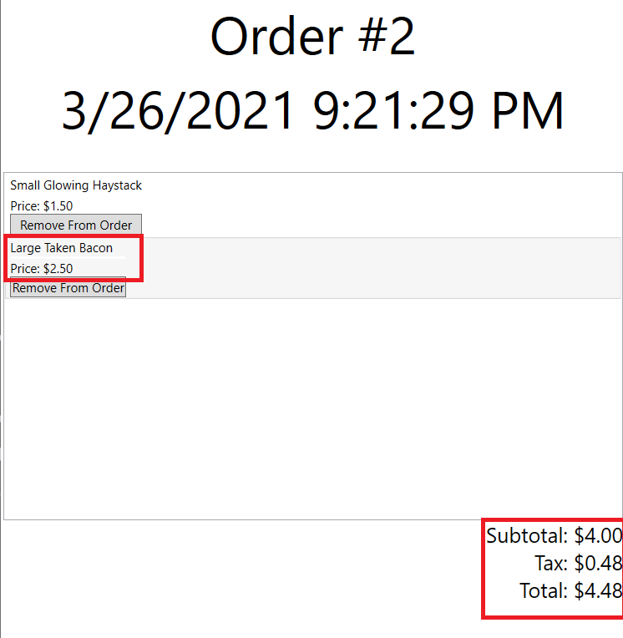
2. Click Confirm and press the first “Remove From Order” button to remove the small glowing haystack from the order.
3. press the “cancel order button” to clear the order form and start a new order.

**Drinks**

1. Keep open the existing PointOfSale project from the sides section. The window should look like this with the order being #3. 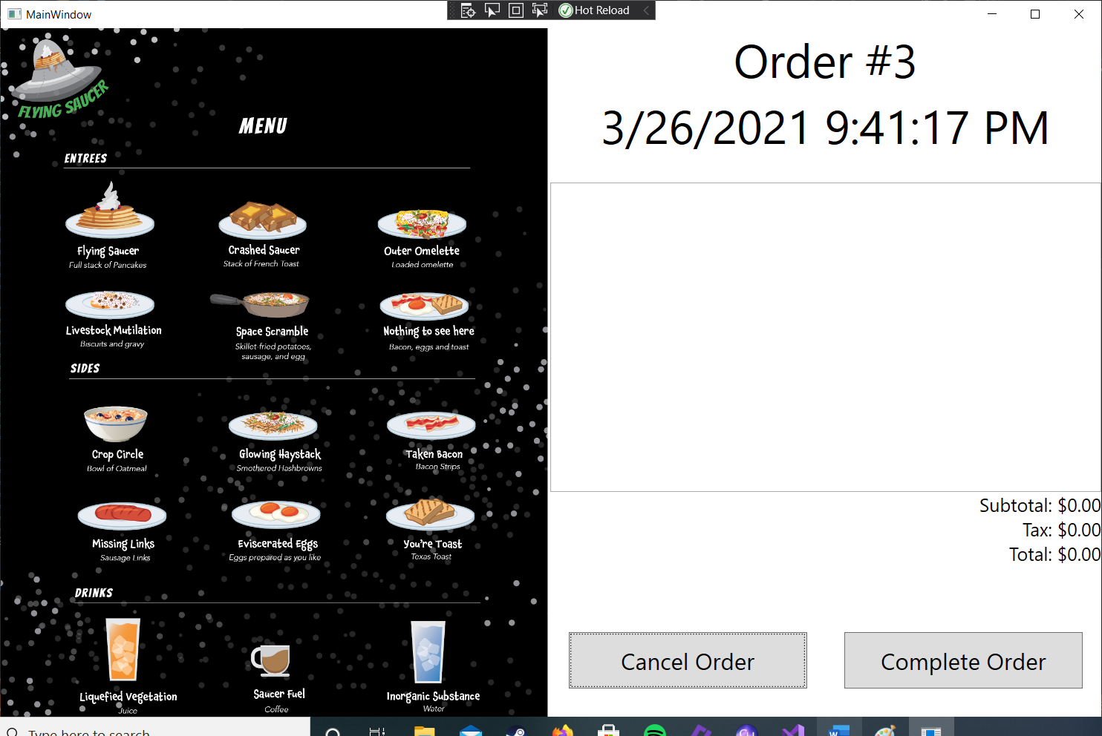
2. Click on the Liquified Vegetation icon to open up the customization menu for that item. The initial screen should look like this, with the Orange and Medium buttons being selected and a Liquified Vegetation item added to the box on the right. 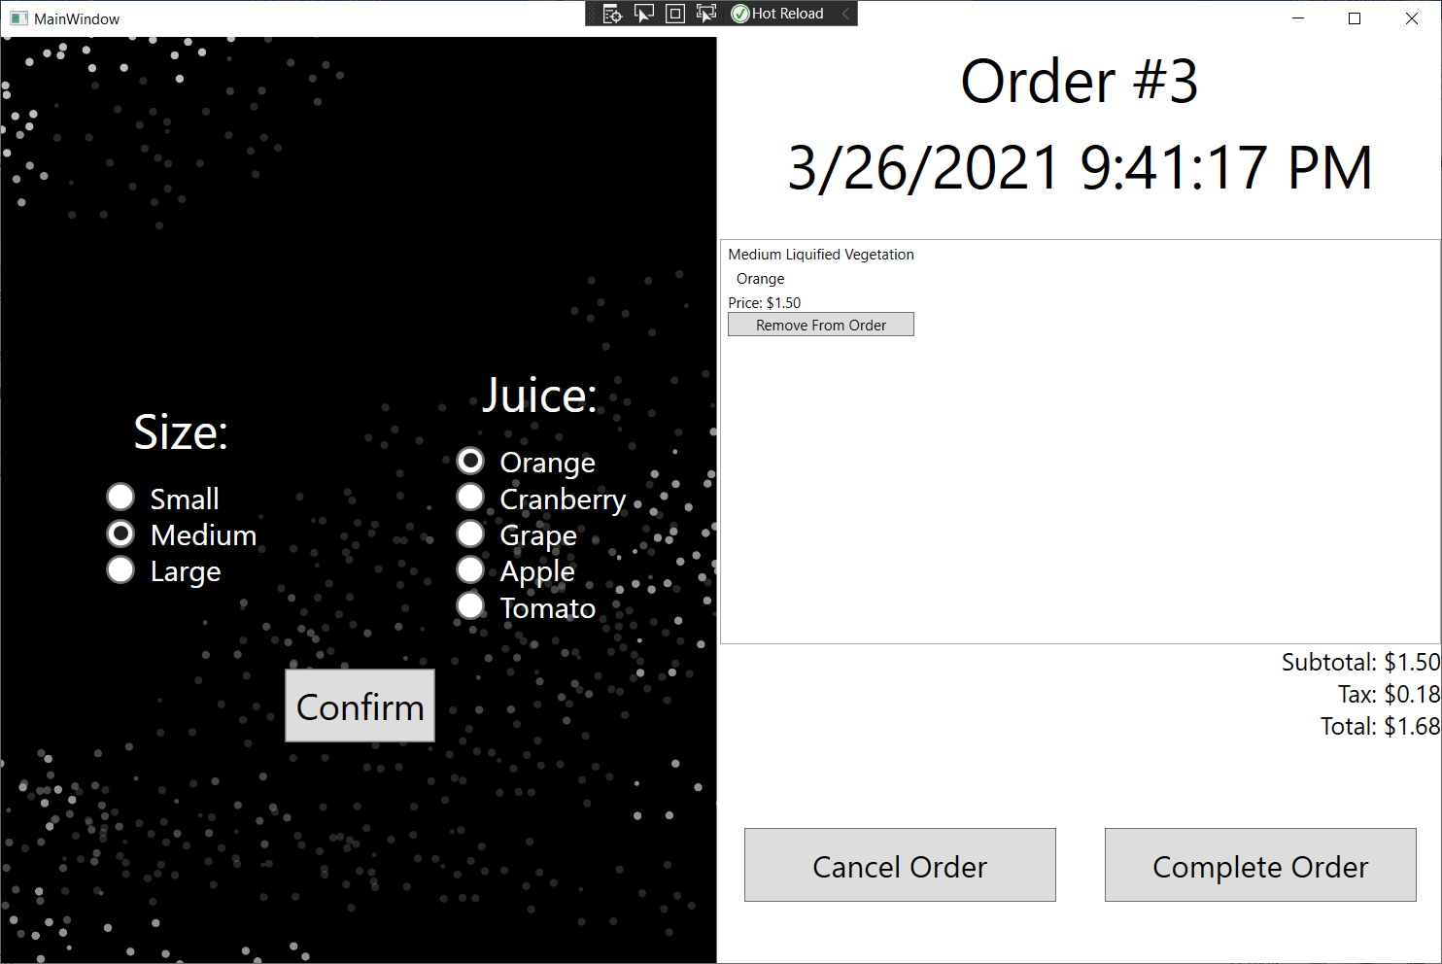

1. Click on the Small button. There should now be the text “Small Liquified Vegetation” in the box containing the order, as well as an adjusted price.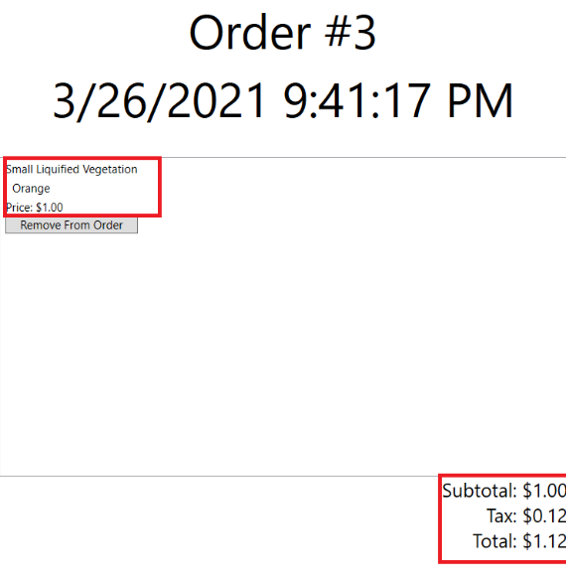
2. Click “Confirm” to go back to the main selection page and select the drink “Inorganic Substance” to open a screen similar to step 2.
3. Click “Confirm” again to go back to the main selection page. Now click in the highlighted area to edit the existing Inorganic Substance (water) drink.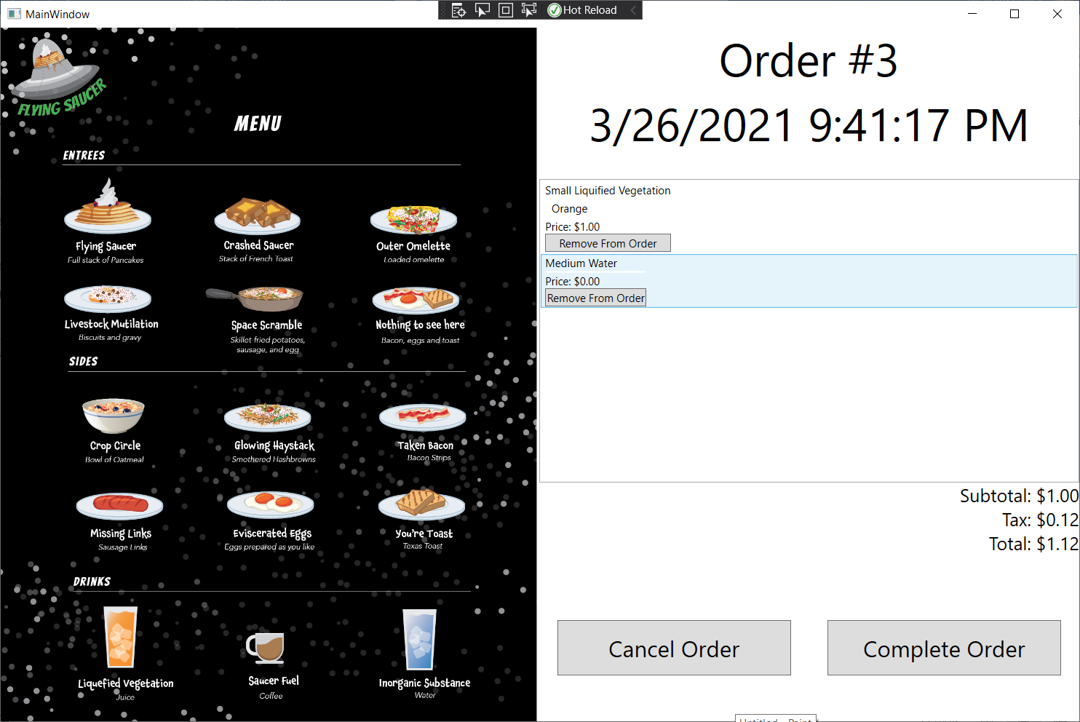
4. Click the “Large” button to adjust the size of the drink. The order form should now be:  
     
   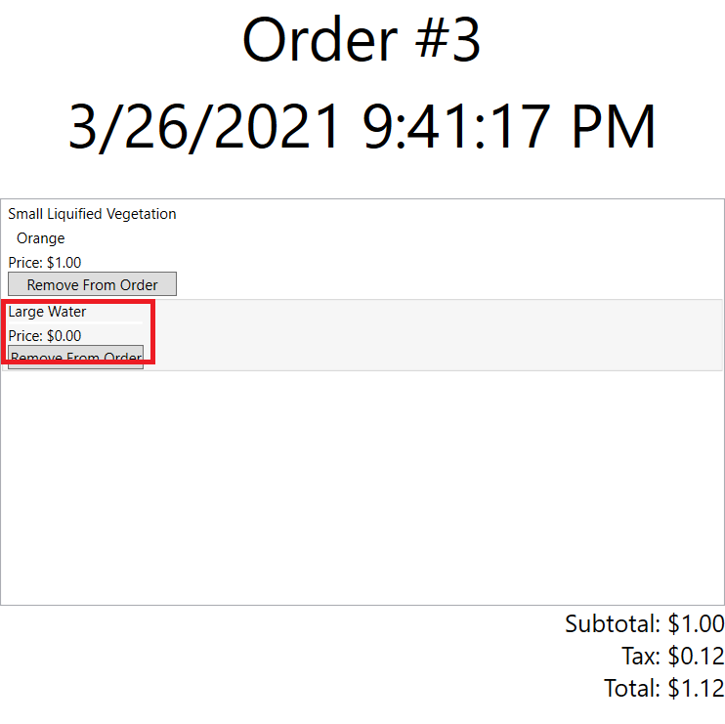
5. Click Confirm and press the first “Remove From Order” button to remove the small liquified vegetation from the order.
6. press the “cancel order button” to clear the order form and start a new order.